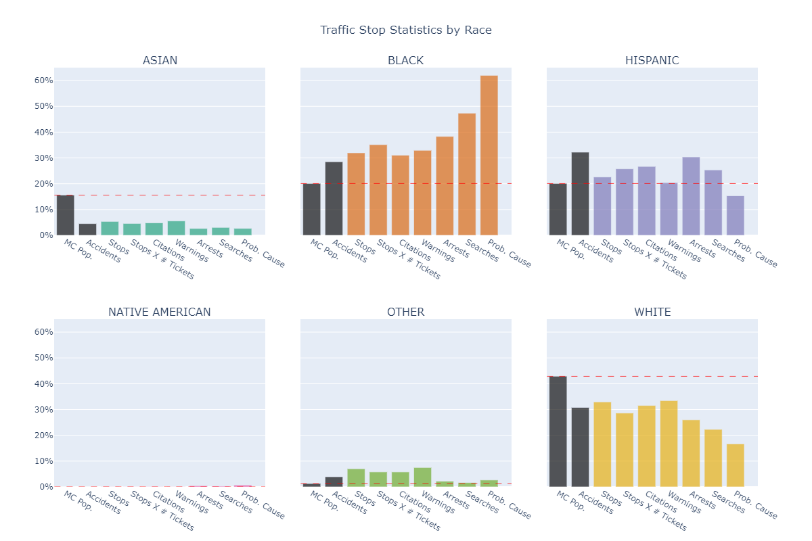

Figure 1

**Meaning of Columns**

**MC Pop.** – This race’s share of Montgomery County’s population (taken from census data).

**Accidents** – This race’s share of all traffic writeups due to accidents.

**Stops** – This race’s share of all traffic stops.

**Stops X # Tickets** – This race’s share of all traffic writeups. This is different from “Stops” because one stop can have multiple writeups (citations, warnings, and/or repair orders).

**Citations** – This race’s share of all citations.

**Warnings** – This race’s share of all warnings.

**Arrests** – This race’s share of all arrests during traffic stops.

**Searches** – This race’s share of all searches conducted during traffic stops.

**Prob. Cause** – This race’s share of all probable cause searches conducted during traffic stops.

**Interpretation of Figure 1**

**Context**

Figure 1 shows traffic stop summary statistics by race. In each race’s sub-chart, each column represents that race’s share of that column’s total across all races. Take the example of the “Stops” column in the “ASIAN” sub-chart, which has a value (height) of approximately 5% – this means that Asian stops accounted for 5% of all traffic stops.

Figure 1 allows us to visualize over and under-policing of each race. To determine whether a race is receiving an appropriate amount of attention from the MCPD, we first need to estimate how many drivers there are of each race, and how they drive. Then, for each race, we can compare the number of drivers to the number of outcomes (e.g., searches or citations).

Each sub-chart has two blacked-out columns (“MC Pop.” and “Accidents”) which serve as estimates for the number of drivers of each race:

The “MC Pop.” column tells us what percentage of Montgomery County’s population each race composes. The main caveat of using this to estimate driver-population is that some races may be more/less likely to own cars or drive; the greater these differences, the less accurate this estimate is. The horizontal red line in each sub-chart is set to the same height as “MC Pop.”, to make it easier to compare population to traffic stop outcomes.

The other estimate, “Accidents”, is the proportion of all accident-related tickets that were given to this race. “Accidents” is a useful estimate for two reasons: first, accident-related tickets are arguably the least discretionary that police can write,[1] so this is close to a random sample (i.e., it is not strongly influenced by any potential bias in the MCPD); second, some races may drive less safely than others (i.e., have more accidents) – this would lead to drivers of this race being stopped and cited more frequently, even if there is no racial bias in policing. Thus, if “Accidents” is higher than “MC Pop.” for a race, it may indicate that this race drives less safely than average.[2]

**Interpretation and Results**

**Asian**

Asian drivers appear under-policed[3] when their share of Montgomery County’s population is compared to their traffic stop outcomes. However, when comparing Asian traffic stop outcomes to the Asian share of accidents, Asian drivers appear fairly policed. This is not an unreasonable conclusion, since (as of 2006) Asian drivers in the U.S. had 1/3rd as many fatal accidents (per capita) as Hispanic, White, and Black drivers.[4]

1. Fatality and alcohol-related tickets are also non-discretionary, but they each have caveats that make them less useful as population estimates than accident-related tickets. Fatality-related tickets are too rare to be reliable and precise; alcohol-related are too specific and too sensitive to confounding variables to fairly estimate an entire race (e.g., if one race has a higher proportion of young drivers, they will also have a higher proportion of alcohol-related tickets, so their population estimate would be too high).
2. While the purpose of this report is not to label any races as “better” or “worse” drivers on average, it is also unfair to the MCPD to assume that all races drive identically, so this should be taken into consideration.
3. Asian drivers appear under-policed because their share of traffic stop outcomes (e.g., stops, arrests, etc.) is much smaller than their share of MC’s population.
4. <https://crashstats.nhtsa.dot.gov/Api/Public/ViewPublication/810995> (page 2). This statistic comes with the caveat that “Asian” is a wide umbrella, and national statistics may not be pertinent to Montgomery County.